**SCENARIO**

You are an electrical technician in a company producing various electronic printed circuits for domestic applicant (TV, Radio, Heaters…etc.) as attenuators, amplifier, tuners…etc., you are required to apply two port network models and use your knowledge about signal analysis including composite signals and the calculation of the circuit response in case of step input.

**To achieve the assessment criteria for pass (P2.1) you must answer the following task**

**Task 1:**

A twisted cable connects between a Central Office switching circuit (having internal resistance of **200 Ω**) and a Telephone with equivalent resistance of (**200 Ω as a load**). If the twisted cable can be modeled by symmetrical T attenuator (as shown in figure 1) and R1 is R (as shown in table 1) and R2 is 100 $Ω$. **Apply two port model to:**

1. **Find**:
   1. Characteristics impedance **Zo**.
   2. Attenuation in **dB**.
2. **Solve the following practical problems:**
   1. The Telephone does not receive any calls and the input impedance is measured to be as shown in table (1_Row 3 **{your assessor will choose certain column for you}**). **Estimate what is the problem (Justify your estimation) and your proposed solution**.
   2. The Telephone does not receive any calls and the input impedance is measured to be as shown in table (1_Row 4**{your assessor will choose certain column for you}**). **Estimate what is the problem (Justify your estimation) and your proposed solution.**

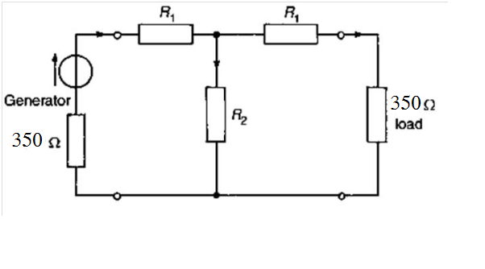

**200Ω load**

**Switching Circuit 200Ω**

**Figure (1)**

|  |  |  |  |  |  |  |  |  |
| --- | --- | --- | --- | --- | --- | --- | --- | --- |
| **Group** | **1** | **2** | **3** | **4** | **5** | **6** | **7** | **8** |
| **R1 Ω** | **100** | **110** | **120** | **130** | **140** | **150** | **160** | **170** |
| **Zin(b_1) Ω** | **150** | **162.38** | **174.55** | **186.52** | **198.33** | **210** | **221.54** | **232.96** |
| **Zin(b_2) Ω** | **200** | **210** | **220** | **230** | **240** | **250** | **260** | **270** |

**Table (1)**

**To achieve the assessment criteria for pass (P2.2) you must answer the following task**

**Task 2:**

1. Design a **T-section** (Figure 2) symmetrical attenuator to provide a **voltage attenuation of X dB** having a characteristic impedance of **Zo**.

* Select values of X and Zo from **table (2) {your assessor will choose certain column for you}** according to your group.
* Prove your answer by simulation using your software package.
  + Put 100 V DC as an input Source.
  + Put Load = Zo as given in the table below.

|  |  |  |  |  |  |  |  |  |
| --- | --- | --- | --- | --- | --- | --- | --- | --- |
| **Group** | **1** | **2** | **3** | **4** | **5** | **6** | **7** | **8** |
| **X in dB** | **14** | **15** | **16** | **17** | **18** | **19** | **20** | **21** |
| **Zo Ω** | **200** | **200** | **200** | **200** | **200** | **200** | **200** | **200** |

Table (2)

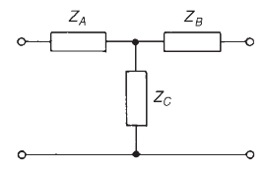

Figure (2)

1. Design a $π$**-section** (Figure 3) symmetrical attenuator to provide a **voltage attenuation of X dB** having a characteristic impedance of **Zo**.

* Select values of X and Zo from **table (3) {your assessor will choose certain column for you}** according to your group.
* Prove your answer by simulation using your software package.
  + Put 100 V DC as an input Source.
  + Put Load = Zo as given in the table below.

|  |  |  |  |  |  |  |  |  |
| --- | --- | --- | --- | --- | --- | --- | --- | --- |
| **Group** | **1** | **2** | **3** | **4** | **5** | **6** | **7** | **8** |
| **X in dB** | **14** | **15** | **16** | **17** | **18** | **19** | **20** | **21** |
| **Zo Ω** | **200** | **200** | **200** | **200** | **200** | **200** | **200** | **200** |

Table (3)

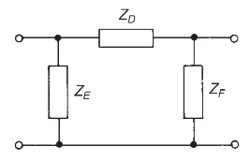

Figure (3)

**To achieve the assessment criteria for pass (P3.2) (Part 1/2) you must answer the following task**

**Task 3:**

Use your software simulator to analyze complex waves as input from a function generator as shown in figure (4):

**Use input wave:**

* Triangle wave.
* Square wave.

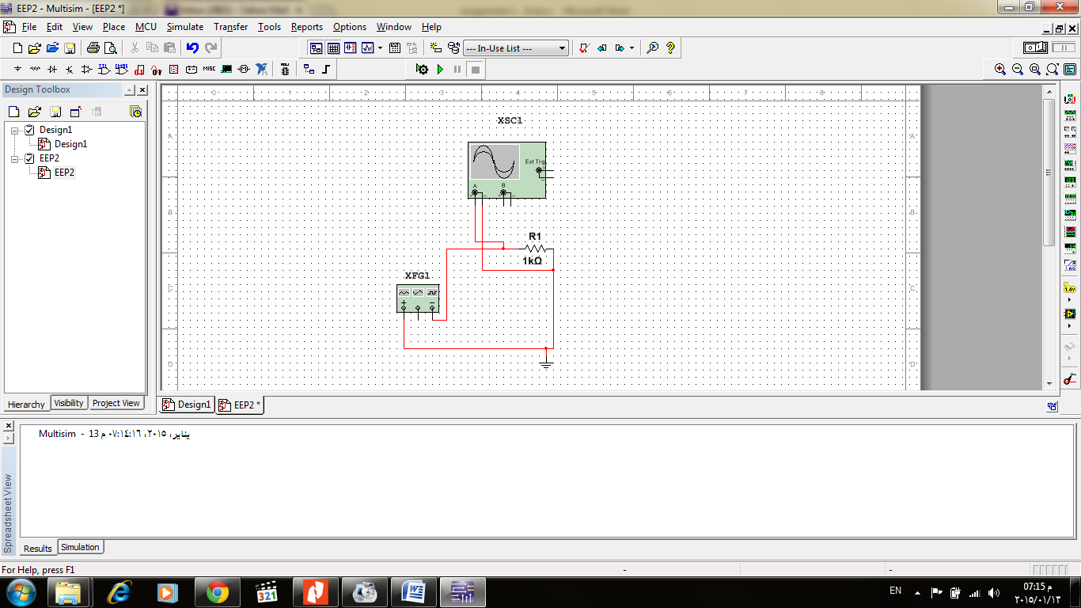

Figure (4)

**Note:**

* Analyze: Find the first 3 harmonic amplitudes.
* Use the frequencies and peak amplitudes as shown in table (4) **{your assessor will choose certain column for you}**.

|  |  |  |  |  |  |  |  |  |
| --- | --- | --- | --- | --- | --- | --- | --- | --- |
| **Group** | **1** | **2** | **3** | **4** | **5** | **6** | **7** | **8** |
| **Frequency kHz** | **10 kHz** | **20 kHz** | **30 kHz** | **40 kHz** | **50 kHz** | **60 kHz** | **70 kHz** | **80 kHz** |
| **Peak Amplitude** | **10 Volts** | **10 Volts** | **10 Volts** | **10 Volts** | **10 Volts** | **10 Volts** | **10 Volts** | **10 Volts** |

Table (4)

**To achieve the assessment criteria for pass (P4.1)(Part 1/2) you must answer the following tasks**

**Task 4:**

Use Laplace transforms for the transient analysis of the network shown in figure (5)

**Note:**

* Transient analysis (find i(t) , VL(t))
* You can use the Laplace Transform table (5).

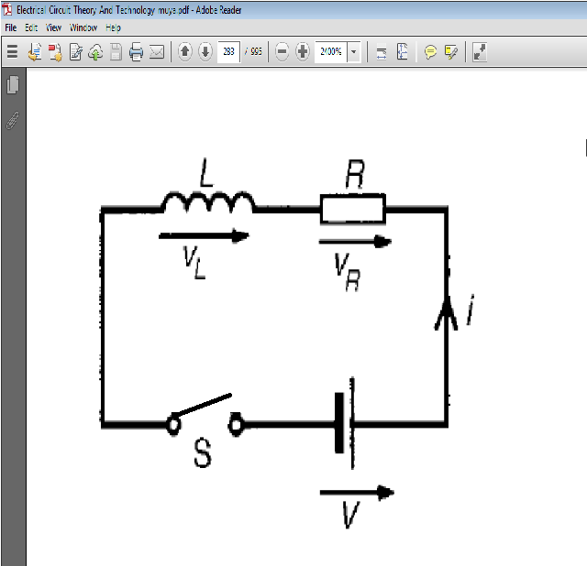

Figure (5)

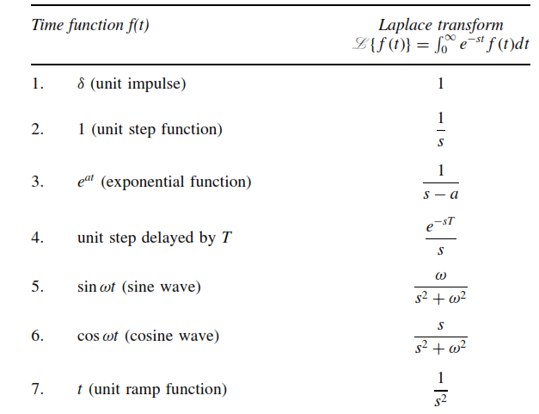

Table (5)

**If L=100mH, R= as in table (6) {your assessor will choose certain column for you} and *V*=5V answer the following:**

Calculate the current passing through the resistor R after time T as shown in table (7) from closing the switch in figure (5) Record your results in table (7).

|  |  |  |  |  |  |  |  |  |
| --- | --- | --- | --- | --- | --- | --- | --- | --- |
| **Group** | **1** | **2** | **3** | **4** | **5** | **6** | **7** | **8** |
| **R in (Ω)** | **50** | **75** | **100** | **125** | **150** | **175** | **200** | **225** |

Table (6)

|  |  |  |  |  |  |
| --- | --- | --- | --- | --- | --- |
| $$\frac{5L}{R}$$ | $$\frac{4L}{R}$$ | $$\frac{3L}{R}$$ | $$\frac{2L}{R}$$ | $$\frac{L}{R}$$ | **Time** |
|  |  |  |  |  | **The Current in (mA)** |

Table (7)

**To achieve the assessment criteria for pass (P4.2) you must answer the following task**

**Task 5:**

A DC motor with armature winding with (L mH inductance) is connected to a DC source with (Vs= 20 Volts and internal resistance R Ω) via long cable with stray capacitance of (C µF) the behavior of the motor differs each time the switch "S" closed if {different motor (different L) or DC supply type (different internal resistance R) or different Cable length (different C)} are used.

**Apply circuit response to calculate the transient current (current as a function of time, iL(t), for all t) and the damping case in only the two cases assigned to you of the following cases according to table (8) {your assessor will choose certain column for you}:**

**A) R= 0 Ω, L=50mH and C=1μF**

**B) R=150Ω, L=75mH and C=1μF**

**C) R=200Ω, L=10mH and C=1μF**

**D) R=250Ω, L=15mH and C=1μF**

**E) R=0 Ω, L=150mH and C=1μF**

**F) R=350Ω, L=20mH and C=1μF**

**G) R=400Ω, L=15mH and C=1μF**

**H) R=450Ω, L=225mH and C=1μF**

**I) R=500Ω, L=25mH and C=1μF**

|  |  |  |  |  |  |  |  |  |
| --- | --- | --- | --- | --- | --- | --- | --- | --- |
| **8** | **7** | **6** | **5** | **4** | **3** | **2** | **1** | **Group** |
| **H&I** | **G&H** | **F&G** | **E&F** | **D&E** | **C&D** | **B&C** | **A&B** | **Cases** |

Table (8)

**Given that: iL(t = 0 ) = 0 A and step voltage of VS = 30 V.**



**Figure (6)**